42.30: a) Solving Eq. (42.23) for the voltage as a function of current,
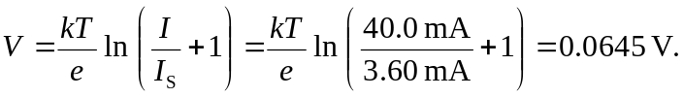
b) From part (a), the quantity 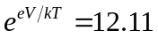, so far a reverse-bias voltage of the same magnitude,


